[Competitor Research] JP Market - AI Application in CS

Background
Recent feedback from the JP market indicates a key user pain point: customers report being “Unable to reach a human representative (only AI Support).”
To address this, the UXA Team conducted a focused competitor analysis to understand how key players in Japan’s travel sector handle the transition from AI-driven support to human agents.

Research Objectives:
- To assess the scope and depth of AI technology adoption within customer service operations in Japan's travel industry.
- To evaluate the ease and efficiency with which users can access a human customer service representative via both phone (IVR/ASR) and live chat channels.

Methodology
A structured, hands-on evaluation of publicly accessible customer service channels, simulating a standard user journey to request agent assistance.

1. Target Competitors
OTA | Airline | Hotel
- Agoda (https://www.agoda.com/ja-jp/）  - Booking.com (https://www.booking.com/index.ja.html?)  - Expedia (https://www.expedia.co.jp/)  - Rakuten Travel (https://travel.rakuten.co.jp/)  - Jalan (https://www.jalan.net/)  - Airbnb (https://www.airbnb.jp/)  - JTB (https://www.jtb.co.jp/)  - HIS (https://www.his-j.com/Default.aspx)  - Airtrip (https://www.airtrip.jp/) | - ANA (https://www.ana.co.jp/)  - JAL (https://www.jal.co.jp/jp/ja/help/)  - Jetstar Japan (https://www.jetstar.com/jp/ja/home)  - Peach Air (https://cs.flypeach.com/hc/ja) | - Hoshimo Resorts (https://hoshinoresorts.com/jp/)  - Okura Hotels & Resorts (https://www.okura-nikko.com/ja/)  - Tokyu Hotel (https://www.tokyuhotels.co.jp/index.html)  - APA Hotels & Resorts (https://www3.apahotel.com/)  - Toyoko Inn (https://www.toyoko-inn.com/eng/)

To make sure the awareness in JP, we also target another 11 brands which are well-known in JP(Like, PayPay, NT DOCOMO, Sony, Nintendo)

2. Research Structure
Phase 1: Channel Mapping & Discovery
- Focus: Document the customer service landscape for each competitor.
- Actions: Locate all service entry points on their website and mobile app. Catalog available channels (phone, chat, email, etc.) .

Phase 2: Call Support Deep-Dive
- Focus: Analyze the voice-based customer service journey.
- Actions: Place testing call. Record observations on:
- System Type: IVR (menu-based) vs. ASR (voice-driven).
- Agent Accessibility: The explicit path (menu sequence or voice command) to request a live agent.
- Experience Metrics: Perceived complexity, clarity of instructions.
- Keyword Triggers (If ASR): Test if phrases indicating complex or sensitive issues bypass automated systems.

Phase 3: Chat Support Deep-Dive
- Focus: Deconstruct the digital chat experience.
- Actions: Initiate chat session. Systematically record:
- First Response: Automated chatbot vs. immediate human agent.
- Chatbot Capability & Flow: Analyze its menu logic and problem-solving scope.
- Escalation Mechanism: How is a live agent requested? Is it via menu option, specific command, or automatic trigger?
- Interface Design: Presence and prominence of a dedicated button for agent access.
- Keyword Triggers: Test if phrases indicating complex or sensitive issues bypass automated systems.

Findings
Research-used recording file: Competitor Research: JP Market - AI Application in CS

Service Channel Mapping:

Baseline mapping of competitors’ service channels.
Trip.com covers the common service channels among the target competitors.
- Phone calls are the most common service channel in the Japanese market.
Only 1 airline company, "Jetstar", did not find the Call Number.
- The Chat channel commonly uses AI.
Booking.com did not find the AI application in the service function.
- Some brands use email, but do not display it as a high-priority channel
- LINE, Japan’s leading social media app, can serve as a contact channel.

Comparison Table as below(please unfold):
Industry | Brand | Call | Chat | AI | Email | Special Service Feature
OTA | Trip.com-JP | Yes | Yes | Yes | No | No
OTA | Agoda-JP | Yes | Yes | Yes | No | LINE
OTA | Booking.com-JP | Yes | Yes | No | Yes | No
OTA | Expedia-JP | Yes | Yes | Yes | No | No
OTA | Rakuten Travel-JP | Yes | Yes | Yes | Yes | No
OTA | Jalan-JP | Yes | Yes | Yes | Yes | No
OTA | Airbnb | Yes | Yes | Yes | No | No
OTA | JTB | Yes | No | No | No | No
OTA | HIS | Yes | No | No | Yes | No
OTA | Airtrip | Yes | Yes | Yes | Yes | No
Airlines | ANA | Yes | Yes | Yes | Yes | LINE
Airlines | JAL | Yes | Yes | Yes | Yes | No
Airlines | Jetstar捷星 | No | Yes | Yes | No | No
Airlines | Peach乐桃 | Yes | Yes | Yes | No | No
Hotels | 星野集团 Hoshimo Resorts | Yes | No | No | Yes | No
Hotels | 大仓酒店 Okura Hotels & Resorts | Yes | No | No | Yes | No
Hotels | 东急 Tokyu Hotels | Yes | Yes | Yes | No | No
Hotels | APA Hotels & Resorts | Yes | No | No | Yes | No
Hotels | 东横INN | Yes | No | No | Yes | No
Bank | Paypay | Yes | Yes | Yes | Yes | LINE
Bank | Rakuten Bank | Yes | Yes | Yes | Yes | No
Logistics | Yamato Transport | Yes | No | No | Yes | No
Logistics | Japan Post | Yes | No | No | Yes | No
Logistics | 佐川急便（Sagawa Express） | Yes | No | No | Yes | LINE
Telecom | NTT DOCOMO | Yes | Yes | Yes | No | No
Telecom | AU KDDI | Yes | Yes | Yes | No | No
Telecom | SOFTBANK | Yes | No | No | No | Call-Back Appointment
Life | Panasonic | Yes | Yes | Yes | No | No
Life | Sony | Yes | Yes | Yes | Yes | LINE
Life | Nintendo | Yes | Yes | Yes | No | X

Call Support
There is no call channel for Airlines Jetstar. So 29 samples are valid for the call.

Call Entrance
Trip.com’s path to the customer service phone number is easy, it’s simpler than most OTAs, many of which require more than 6 steps.
- Easy: Trip.com, JTB, and Toyoko Inn need fewer than 3 steps to access the CS number.
- Normal: 6 brands' paths to the call-number are within 5 steps.
- Hard: 6 brands (OTAs and airlines) require more than 6 steps to find the call option, resulting in the worst experience.

Access to phone number steps analysis:
Access to Phone Number-Effort Level | Industry | Quantity
1-3 Steps | Hotels | 1
 | Trip.com | 1
 | OTA | 1
4-5 steps | Hotels | 4
 | Telecom | 3
 | OTA | 3
 | Logistics | 3
 | Life | 3
 | Bank | 2
 | Airlines | 2
6 steps above | OTA | 5
 | Airlines | 1
Sum |  | 29

IVR or ASR application
Airbnb and PayPay Bank use IVR+ASR for their call channels, while other competitors still rely on IVR menus for call flows.
ASR Sensitive words: (Paypay, hands up the phone, no matter what the caller says.)
Airbnb ASR Logic is "Leave the "Press 0" option to the customer for each reply by ASR.(Sensitive word or other general queries)
ASR feature: Even some brands use the ASR tech, but the IVR menu is still the option for customers to access the human agent(If the ASR does not recognise the voice, the IVR menu would say "Please press x to access the human agent)
Only Peach(Airline) provides the direct human agent option in the IVR Menu

Access to the agent
More than half of competitors (21/29) limit IVR menu depth to 3 levels or fewer, making it easy for customers to reach the human agent queue.

- Trip.com JP set a different logic in different travel product. Eg, Hotel Call is IVR Menu but Flight Call is ASR.
It's confusing when customers call the same number and get a different call flow.
- Trip.com Hotel IVR-Easy to access human: Press 1(Hotel)->Press 1(Existing Reservation)->Even not inputting the reservation phone number->To the human agent queue.
- Trip.com Flight ASR-Not Smart Understanding: Press 2(Flight) Try 5 times and prompt that if not solved, transfer to an agent.

Access to phone human agent analysis:
IVR-Access to Human Agent-Effort Level | Industry | Quantity
1-3 Steps | OTA | 7
 | Hotels | 4
 | Logistics | 3
 | Telecom | 3
 | Bank | 1
 | Trip.com | 1
 | Airlines | 1
 | Life | 1
4-5 steps | OTA | 2
 | Airlines | 2
 | Hotels | 1
 | Bank | 1
6 steps above | Life | 2
Sum |  | 29

AI+Chat Support
There are 20 valid samples. Notably, Booking.com does not use AI for customer service, while the rest of the 19 targets use the "AI+Chat" module.

Chat Entrance
Placing the chat channel in the bottom-right corner of the homepage is best practice; Trip.com does this.
- Easy: Trip.com and 10 competitors(4 Airlines and 4 OTA) set the Chat Entrance as a priority service channel, which can be found within 3 steps.
- Normal: No target is in 4-5 steps to access the chat entrance.
- Hard: 8 targets(included Booking and Airbnb) make more steps to access the Chat Entrance.

Chat Entrance steps analysis:

Access to Chat Entrance | Industry | Quantity
1-3 Steps | OTA | 5
 | Airlines | 4
 | Trip.com | 1
 | Bank | 1
 | Hotels | 1
6 steps above | Life | 3
 | Telecom | 2
 | OTA | 2
 | Bank | 1
No chat | Hotels | 4
 | Logistics | 3
 | OTA | 2
 | Telecom | 1
Sum |  | 30

AI Robot feature

AI robot interaction logic.
Trip JP(Radom FAQ)  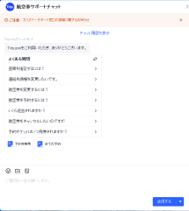 | Agoda (FAQ+Topic)  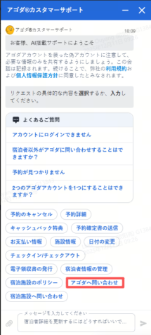 | Expedia JP (Topic)  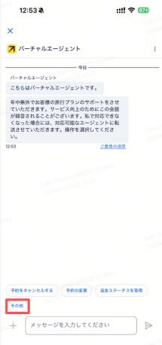 | Rakuten Travel JP(Product)  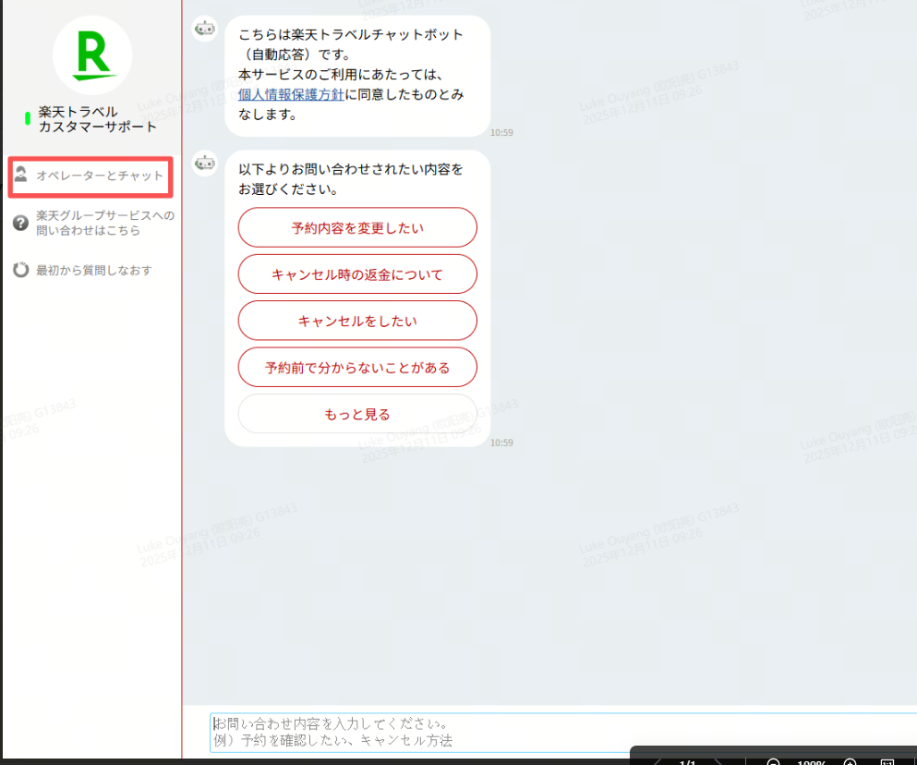 | ANA JP(Product)  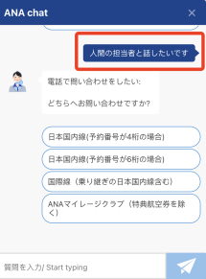

Human Agent Tags
Trip.com  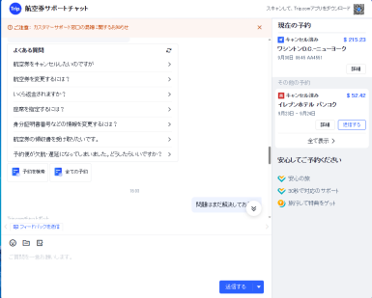 | Rakuten Travel JP   | NT DOCOMO  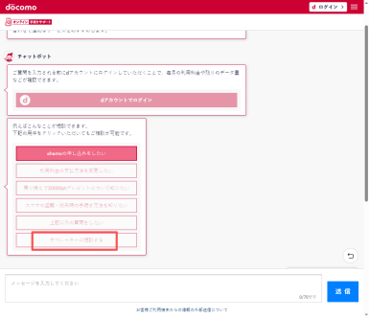

Clear to require a human agent
Trip.com JP (Reply line busy and not trigger Human Agent)  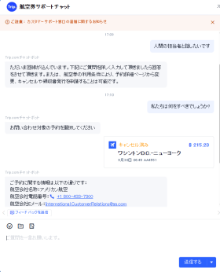 | Agoda JP  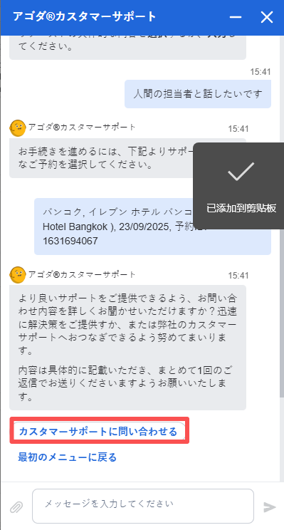 | Expedia JP  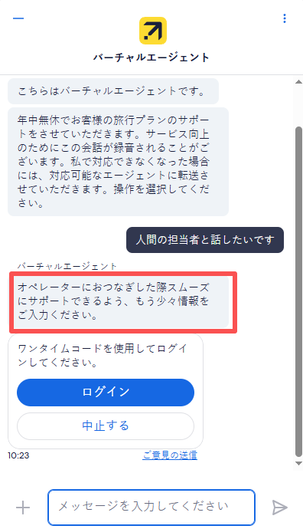 | Airline Peach  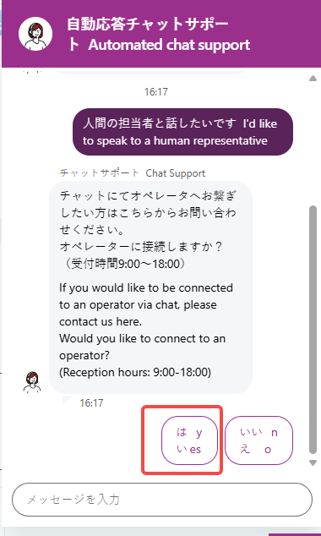

Sensitive Words
The competitor has launched similar logic for handling sensitive word input.
Expedia JP  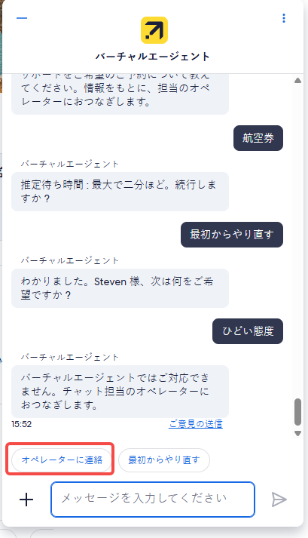 | Airbnb  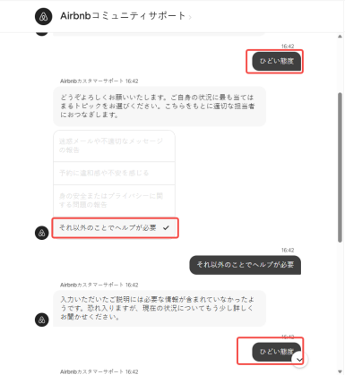 | Peach 乐桃  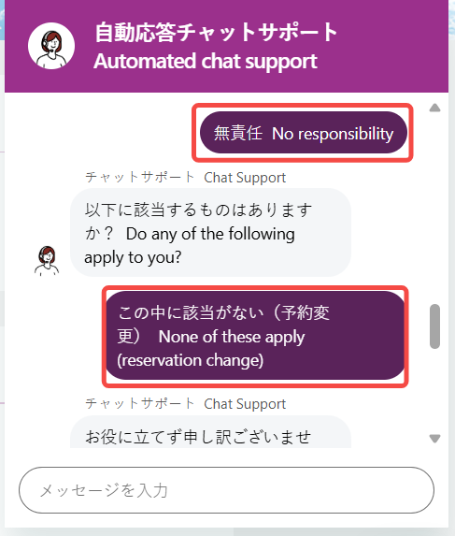  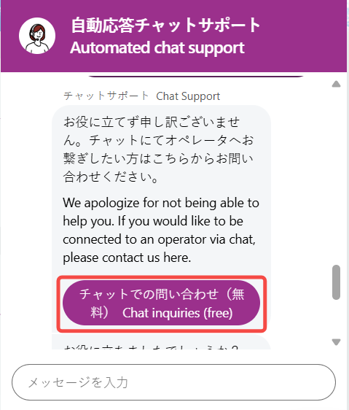

Detail:
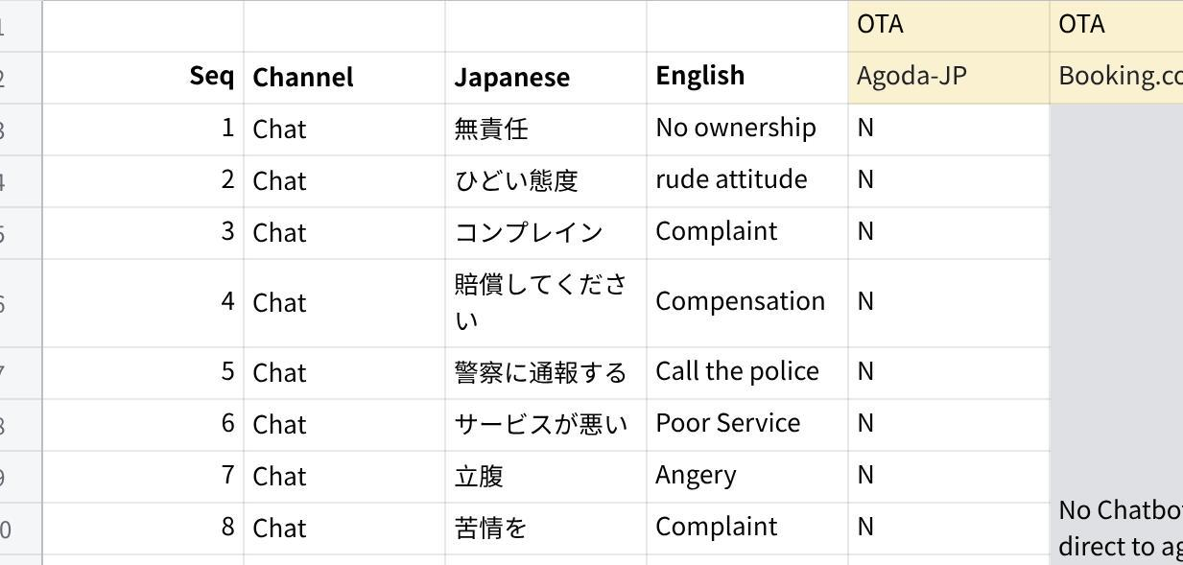
点击图片可查看完整电子表格

Access to the agent
We found that 14 brands provide human agent service, which 20 have chat channel.

Chat is the priority channel, and AI is embedded in the chatroom.
- Easy: Rakuten Bank and NTT DOCOMO lead by offering one-step access to a human agent: the “Human Agent” button is always visible in the chatroom.
- Normal: If an issue remains unresolved after 2–3 interactions and the feedback is “not solved,” JP Airline will transfer the conversation to a human agent.
- Hard: Trip.com is here because, as long as no sensitive language is triggered, the AI will keep answering questions.

Access to chat human agent analysis:
Access to Human Agent | Industry | Quantity
1-3 Steps | Telecom | 1
 | OTA | 1
4-5 steps | Airlines | 3
 | Life | 1
 | OTA | 1
 | Bank | 1
6 steps above | OTA | 3
 | Airlines | 1
 | Trip.com | 1
 | Telecom | 1
No human agent | OTA | 2
 | Life | 2
 | Hotels | 1
No robot | OTA | 1
No chat | Hotels | 4
 | Logistics | 3
 | OTA | 2
 | Telecom | 1
Sum |  | 30

Pros & Cons：
Pros：  - Call & Chat Entrance is easy to access(Better than or same as Agoda, Booking, Expedia)  - Sensitive words work to transfer to human agent quickly. | Cons:  - Call-IVR and ASR separated by product cause confusion. It's better to align.  - Call-ASR(Flight) doesn't recognise speech accurately, and there’s no option to connect to a human agent even after more than two unrecognised attempts.  - Chat-Lack of the human agent button  - Chat-If not the sensitive word input, AI robots keep answering the questions till the customer inputs "Lawyer"  (ChatID:800000915128060)

Executive Summary
Our research into the Japanese market reveals a critical gap: while our service channels are easy to find, our process for escalating from AI to a human agent is significantly harder than our competitors'. This is the direct cause of the user pain point "Unable to reach a human representative."

The Core Problem:
- Chat: We lack a clear "Contact Agent" button, forcing frustrated users into an AI loop. Competitors like Rakuten provide this as a standard feature.
- Call: We use a confusing mix of IVR and ASR for different products. The ASR for flights performs poorly and traps users without an option to speak to a person.

Key Recommendations
- Strategically Introduce a Human Agent Path in Chat :The core issue is the lack of an escape from our chat AI. Instead of a universally visible "Contact Agent" button which could strain resources, we propose a conditional button.
- Action: Add a "Contact Human Agent" button that appears only after the AI fails twice.
- Next Step: Pilot this with a small user segment, measure the impact on chat volume and service levels, then adjust accordingly. This balances user experience with operational capacity.
- Unify the Call Experience :
- Action: Replace the confusing mix of IVR/ASR with a single, simple IVR menu for all products. Crucially, this menu must offer an early option (e.g., "Press 0") to speak to a human. This is a basic market expectation we are currently failing to meet.

Next Action
# | Action item | Details | PIC | Link
1 | Add a "Contact Human Agent" button | Add a "Contact Human Agent" button that appears only after the AI fails twice.

Appendix
Past research (For REFERENCE ONLY):
- AI Operation Team: JP AI ASR Market Research Report.pptx
- UXA Team: Competitor Analysis; Survey: Customer Expectation & Preference of ASR

